**Food Drive**

* Process: fill the bag and it will be picked up Saturday, Sept 9
* Items that can not be delivered or picked up on Saturday September 9 can be dropped off at our Mountain Rose Women’s shelter office location at 4708 – 46 street Rocky Mtn House, Monday to Friday between 8:30 AM and 4PM
* Cash Donations, gift cards and activity passes are greatly appreciated

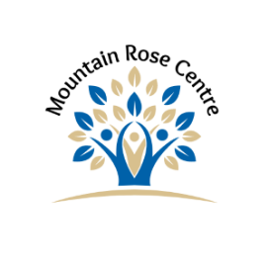Basic Needs

Canned Goods

* Meat
* Vegetables
* Fruit
* Pasta & Sauces

Back to School Snacks

Rice

Cooking Oil

Flour, Sugar & Baking Supplies

Condiments (Mayo, Ketchup, etc.) & Spices

Peanut Butter, Honey & Jam

Jello pudding and mixes

Cereal – hot and cold

Coffee – grounds, filters, whitener

Juice crystals, juice

Gluten or Sugar Free items

Consumable Products

Toilet Paper, Paper Towels & Kleenex

Shampoo & Conditioner

Fabric Softener Sheets

Dish Soap & Dishwasher Soap

Cleaning Products

Garbage Bags – All sizes

Ziploc Bags & Freezer Bags – M, L and XL

Saran Wrap and Tin Foil

Diapers –Size 4, 5 & 6

Baby Wipes

Nail Clippers & Emery Boards

Ladies Razors

Hair Brushes

Deodorant

Feminine Hygiene Products

Clothing Items

Ladies Underwear & Socks sizes S, M, L, XL  
Children’s Socks & Underwear – all sizes

**Food Drive**

* Process: fill the bag and it will be picked up Saturday, Sept 9
* Items that can not be delivered or picked up on Saturday September 9 can be dropped off at our Mountain Rose Women’s shelter office location at 4708 – 46 street Rocky Mtn House, Monday to Friday between 8:30 AM and 4PM
* Cash Donations, gift cards and activity passes are greatly appreciated

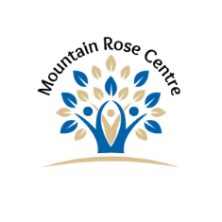

Basic Needs

Canned Goods

* Meat
* Vegetables
* Fruit
* Pasta & Sauces

Back to School Snacks

Rice

Cooking Oil

Flour, Sugar & Baking Supplies

Condiments (Mayo, Ketchup, etc.) & Spices

Peanut Butter, Honey & Jam

Jello pudding and mixes

Cereal – hot and cold

Coffee – grounds, filters, whitener

Juice crystals, juice

Gluten or Sugar Free items

Consumable Products

Toilet Paper, Paper Towels & Kleenex

Shampoo & Conditioner

Fabric Softener Sheets

Dish Soap & Dishwasher Soap

Cleaning Products

Garbage Bags – All sizes

Ziploc Bags & Freezer Bags – M, L and XL

Saran Wrap and Tin Foil

Diapers –Size 4, 5 & 6

Baby Wipes

Nail Clippers & Emery Boards

Ladies Razors

Hair Brushes

Deodorant

Feminine Hygiene Products

Clothing Items

Ladies Underwear & Socks sizes S, M, L, XL  
Children’s Socks & Underwear – all sizes