**35km for 35 years**

**To celebrate MRWSA 35 years in Rocky Mountain House**

**REGISTRATION FORM**

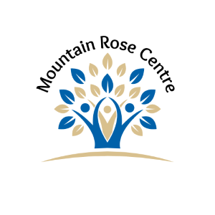

Mountain Rose Women’s Shelters’ 35km for 35 years will be held on Saturday, May 31, 2025, from11am-4pm. Please fill out and return registration form to either our office location at 4708 46th Street or by email lhunt@mrwsa.net. ALL participants must complete the registration form and provide a copy to Mountain Rose Women’s Shelter Association. To collect donations/pledges you must use Mountain Rose Women’s Shelters’ “Pledge Form”.

**NAME:** _______________________________________________________

**Team Name:** __________________________________________________ (if applicable)

**Address:** _____________________________________________________

**Phone Number:** _______________________________________________

**City/Town, Province:** ___________________________________________

**Postal Code:** ____________________

**Email:** _______________________________________________________

There is a $25 registration fee, every participant will receive a swag bag!!

A charitable tax receipt will be issued for donations/pledges of $10 and over.

**Please make cheque(s) payable to Mountain Rose Women’s Shelter Association.**

Disclaimer/Waiver:

In consideration of my entry in the 35km for 35 years as hosted by Mountain Rose Women’s Shelter Association, I, for myself, my heirs, executors and administrators, waive and release any and all rights and claims for damages I have or may hereafter have against the organizers of this event, its principals, its employees, its volunteers, all sponsors and their representatives and all claims of damages, demands, actions whatsoever in any manner, as a result of my participation in the “35km for 35 years” event, including travel to and from this event. I attest and verify that I am physically fit and have sufficiently trained for completion of this event and I have not been advised otherwise by a qualified medical person. Further, I hereby grant full permission to any and all of the foregoing to use my name and likeness in any broadcast, telecast, video or print media of the event without compensation.

**Participant Signature:** ____________________________________ **Date:** ________________

**Parent Signature:** ________________________________________ **Date:** ________________

**of responsible & authorized adult if participant is under 18 years of age**

Mountain Rose Women’s Shelter Association, “35km for 35 years”