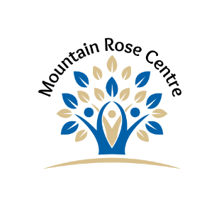

MOUNTAIN ROSE WOMEN’S SHELTER ASSOCIATION
Indigenous Support Worker (Temporary)
Job Description

The Indigenous Support Worker is responsible for guiding and engaging MRC clients in cultural supports and to work collaboratively with other MRC programs to design appropriate activities that meet the cultural needs of clients. The goal of this position is to support Indigenous client goals that bridges cross-sectors of engagement that is participatory, inclusive, deliberative, and collaborative. This position requires a broad skill set centered on cultural awareness, human development, and individual dynamics with a focus on the impacts of domestic violence. This position is based on 40 hours a week.

PRIMARY RESPONSIBILITIES

- Consult and work with MRWSA Staff Team in developing appropriate cultural activities as they relate to the physical, emotional, and social needs of Indigenous clients and/or families.
- Work with the Project Coordinator, Project Elder, and Executive Director to ensure all project objectives are completed as per the Project Workplan.
- Provides guidance, assistance, encouragement, and support to Indigenous clients and others in developing and achieving personal success and life skills goals.
- Purchase supplies and other material for the project, within budget, as approved by the Project Coordinator.
- As identified by the clients’ goals, engage in collaborative community partnerships to promote traditional healing, cultural teachings, and protocols.
- Work with the Project Elder to ensure correct protocols are practiced with Indigenous clients.
- Maintain an inventory of ceremonial items for use. Attain approvals from the Project Coordinator before purchasing items.
- Participates in Intensive Case Management Meetings in support of all clients.
- Ensure all documentation (Outcome Tracker, Client paperwork, and Project related reports) is completed in a timely manner.

STAFF RELATIONSHIPS AND STAFF DEVELOPMENT

To participate fully and consistently in staff development activities by:
- Participate in scheduled staff development meetings, in-services, and training.
- Make consistent efforts to up-grade knowledge and skills in pertinent areas.
- Effectively complete projects as assigned.
- Productively, positively, and consistently participates as a member of the Shelter
Team (consisting of resource people, volunteers, staff, and Board)

WORK ENVIRONMENT

The person holding this position will work irregular hours and may be required to work evenings, weekends, and holidays as necessary to complete assigned duties and responsibilities. Work may be performed in a variety of settings including offices, community events, businesses, and classrooms in the community. Some independent travel throughout the area may be required. Ability to transport clients/families if necessary for client inclusion to cultural support services and/or community engagement.

ADMINISTRATION

- Ensure all agency forms and documentation is current and accurate.
- Submit timesheets and expense claims according to established procedures.
- Maintain a current knowledge of agency Policies and Procedures and ensure their implementation as they apply to this position.

SUPERVISION

The Indigenous Support Worker reports directly to the Project Coordinator and/or the Executive Director.

Employment is dependent upon:

- Criminal record check
- Child welfare information system check
- Valid drivers license and vehicle
- Funding availability
- Reference checks

Performance/Self Evaluation:

As this is a temporary position, the Executive Director of the Mountain Rose Women’s Shelter Association will complete an evaluation of job performance of the Indigenous Support Worker on an ongoing basis throughout the project.

